Chapter 4 Selections

1. <, <=, ==, !=, >, >=

2. Yes. i becomes 1, j becomes 0, b1 becomes True, and b2 becomes Flase.

3. random.randrange(0, 20) or random.randint(0, 19)

4. random.randrange(10, 20) or random.randint(10, 19)
5. random.randrange(10, 50 + 1) or random.randint(10, 50)
6. random.randrange(0, 2) or random.randint(0, 1)

7.

if y > 0:
x = 1

8.

if score > 90:
pay *= 1.03

9.

if score > 90:
pay *= 1.03
else:
pay *= 1.01

10.

If number is 30,
(a) displays
30 is even
30 is odd

(b) displays
30 is even

If number is 35,
(a) displays
35 is odd

(b) displays
35 is odd

11. Note: else matches the second if clause. The output is “x is 3” if x = 3 and y = 2. The output is “z is 7” if if x = 3 and y = 4. No output if if x = 2 and y = 2.

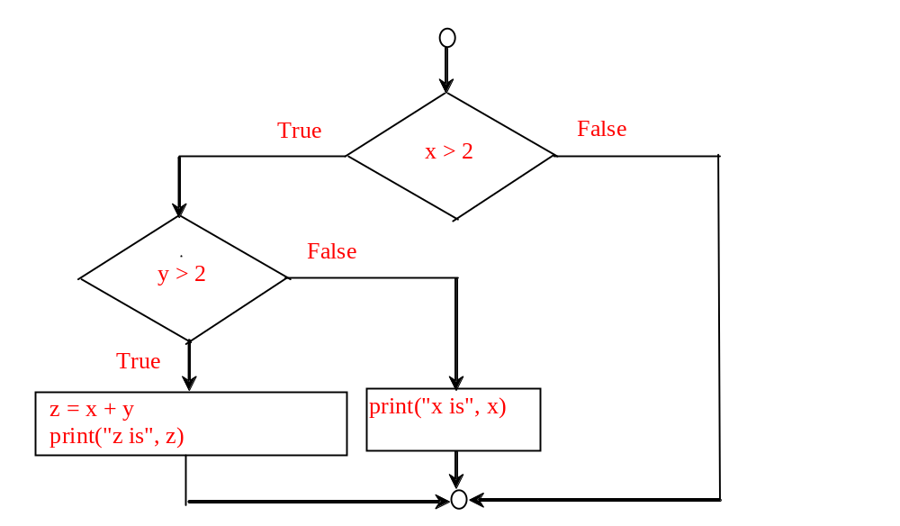
12. Note: else matches the first if clause. The output is “x is 2” if x = 2 and y = 4. No output if if x = 3 and y = 2. The output is “z is 6” if if x = 3 and y = 3.

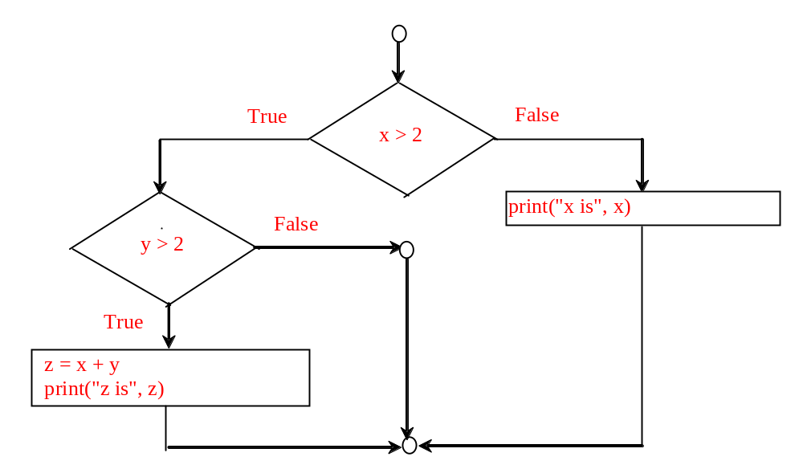

13.
Consider score is 90, what will be the grade? The conditions are tested in the wrong orders.

14.
(A) and (C) are equivalent. (B) and (D) are incorrectly indented.

15.

newLine = (count % 10 == 0)

16.

Both are correct. (B) is better. Both conditions in (A) are tested. In (B) the condition is tested only once.

17.
For number is 14, (a) displays:
14 is even

(b) displays
14 is even

For number is 15, (a) displays:
15 is multiple of 5

(b) displays
15 is multiple of 5

For number is 30, (a) displays:
30 is even
30 is multiple of 5

(b) displays
30 is even

18.
Yes

19.
This program will have a runtime error, because tax will not be created.

20. (true) and (3 > 4)
False

not(x > 0) and (x > 0)
False

(x > 0) or (x < 0)
True

(x != 0) or (x == 0)
True

(x >= 0) or (x < 0)
True

(x != 1) == not (x == 1)
True

21. (x > 1) and (x < 100)

22. ((x > 1) and (x < 100)) or (x < 0)

23.
x >= y >= 0 False

x <= y >= 0 True

x != y == 5 True

(x != 0) or (x == 0) True

24.
Yes

25.
If ch is 'A', the expression is true;
If ch is 'p', the expression is false;
If ch is 'E', the expression is true;
If ch is '5', the expression is false;

26.

(x < y and y < z) is True
(x < y or y < z) is True
not (x < y) is False
(x < y < z) is True
not (x < y < z) is False

27. age > 13 and age < 18

28.

weight > 50 or height > 160.

29.

weight > 50 and height > 160.

30.

(weight > 50 or height > 160) and not (weight > 50 and height > 160)

31. Sorted

32.
ticketPrice = 20 if (ages >= 16) else 10
print(count, end = "\n" if count % 10 == 0 else " ")

33.
A:
if x > 10:
score = 3 * scale
else:
score = 4 * scale

B:
if income > 10000:
tax = income * 0.2
else:
tax = income * 0.17 + 1000

C:
if number % 3 == 0:
print(i)
else:
print(j)

34.
The precedence order of the Boolean operators are not, and, or in this order.

True
True

35.
True

36.
2 * 2 - 3 > 2 and 4 – 2 > 5 False
2 * 2 - 3 > 2 or 4 – 2 > 5 False

37.

Yes. Yes. Yes.

